Ron Crites Stage Set Up For George Joes Tribute Show

Keys-- Yamaha MO6 Roland RD700
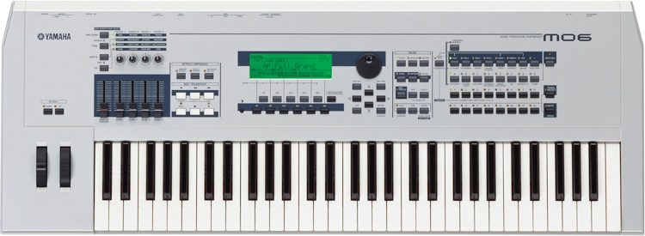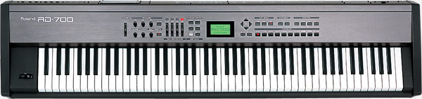

Sound Man Looking Toward The Stage
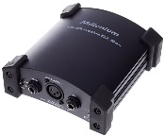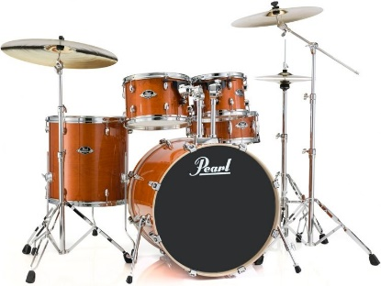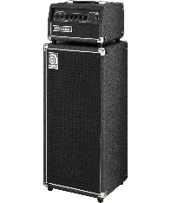
“Piano” “Fiddle” “Drummer” “Bass Player” “Lead Guitar” “Steel Guitar”
DI Box Stereo DI Box Stereo Mic Or D! Box For All 3 Fender DeVille Peavey 400
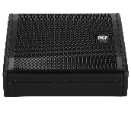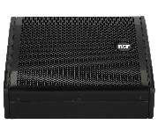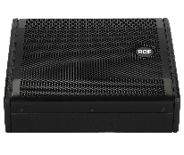
“Monitor” “Monitor” “ Monitor” “Monitor” “Monitor” “Monitor”
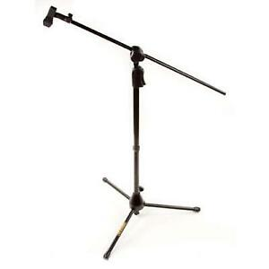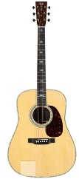
Harmony Singer-1 Harmony singer-2 DI Box For Ron’s Acoustic Martin D41 Acoustic Electric
Note--“Audio Technician Required”
6-Monitors For Band 4-Guitar Stands
2-Monitors For Ron Right & Left Side 6-Music Stands With A Light
4-Microphones For Drummer 1-Double Piano Stand
3-Vocal Microphones, Cables & Booms 1-Fiddle Stand
5-Instrument Mics For Amps

All venues I want the lights bright enough to where I can look in their eyes to see the feelings!

